1. Less filename
2. Less –p ‘anyword’ filename
3. Less –N filename
4. Which vim
5. Which ls
6. Sudo apt install vim-nox
7. Vim
8. Press A,a,I for insertion mode
9. Esc to go out insertion mode and for quitting
10. After step 9 :w filename(for writing in to file)
11. After step 10 :q
12. :q! For quitting without saving
13. If we want to copy from a file to another :r filename
14. If we want to write them into present file :w present filename
15. To delete a line use ‘d’
16. To delete a letter use ‘x’
17. To undo use letter ‘u’
18. head–c (num) filename
19. head–n (num) filename
20. Head –v filename
21. tail–q filename1,filename2
22. tail–c (num) filename
23. tail–n (num) filename
24. tail–v filename
25. tail–q filename1,filename2
26. Head –n 5 filename|tail –n 1
27. Find –name filename

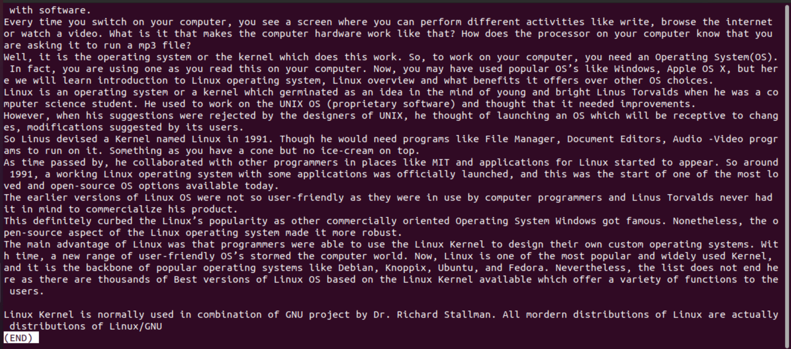

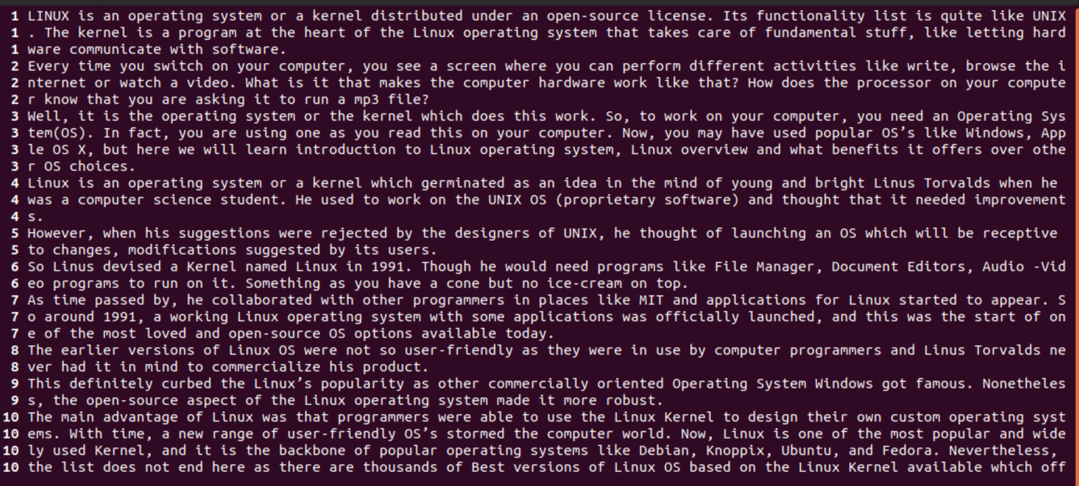

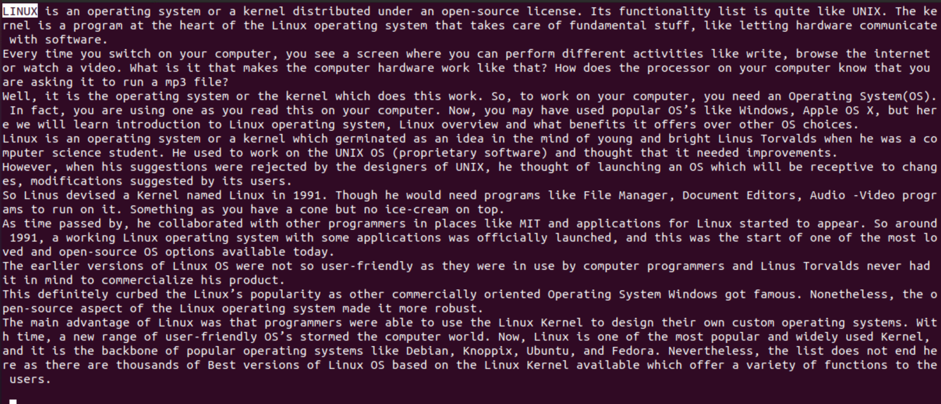

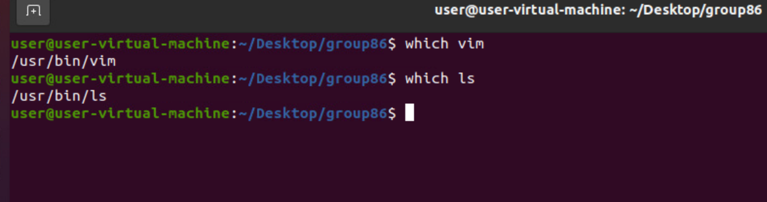

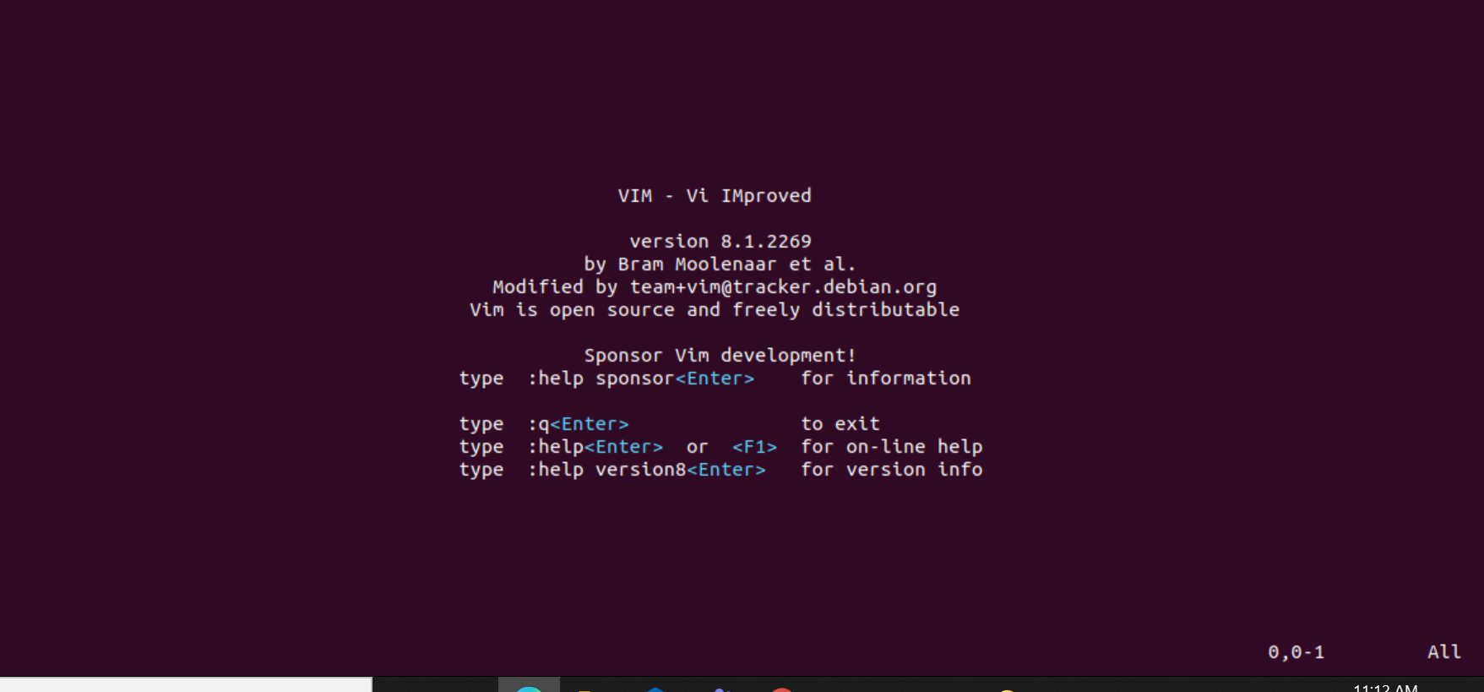

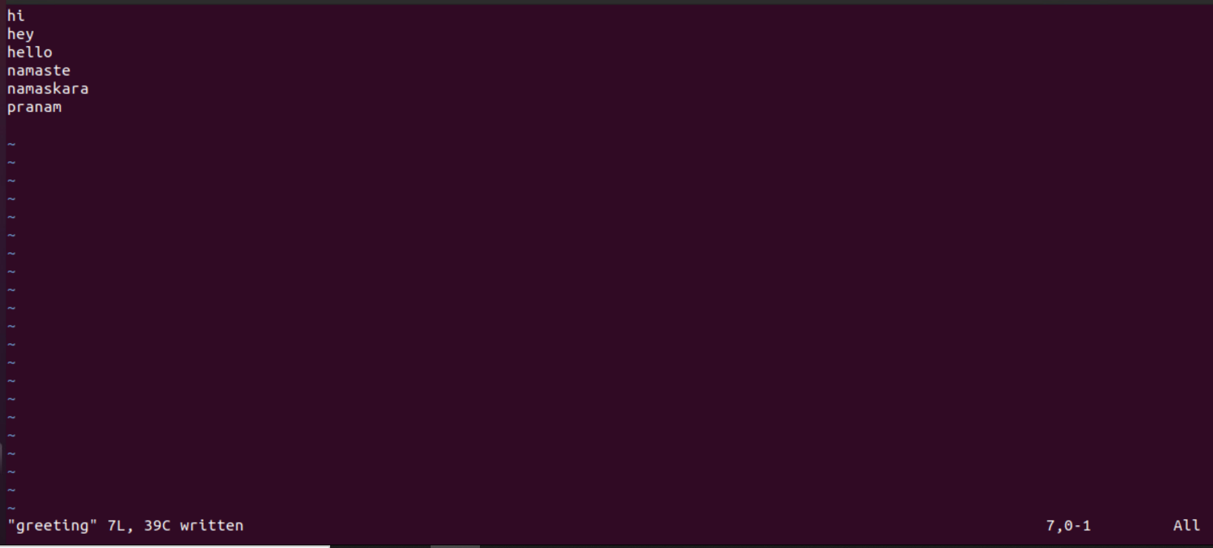

Updated file contents

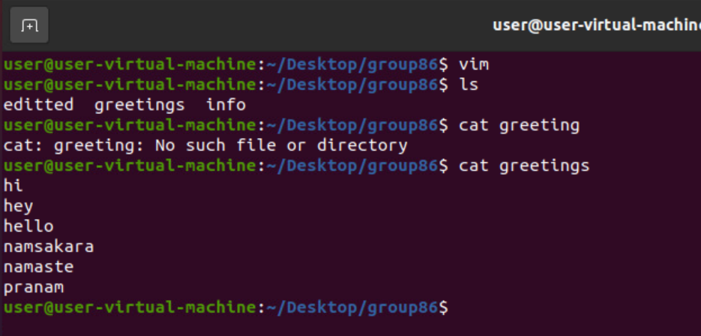

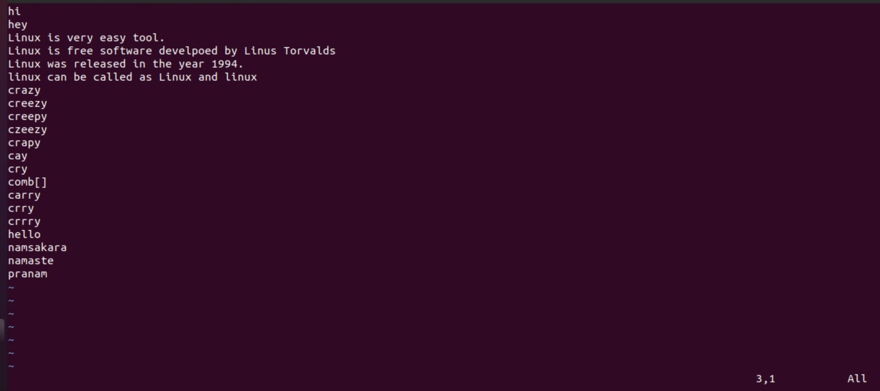

Changes updated after copying file contents to present file

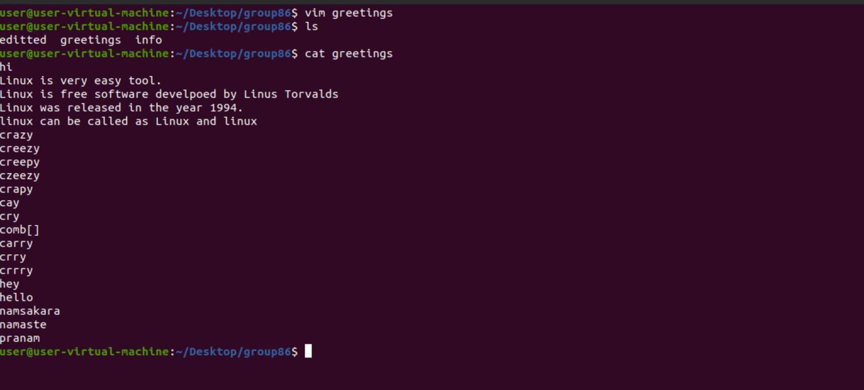

Changes using d key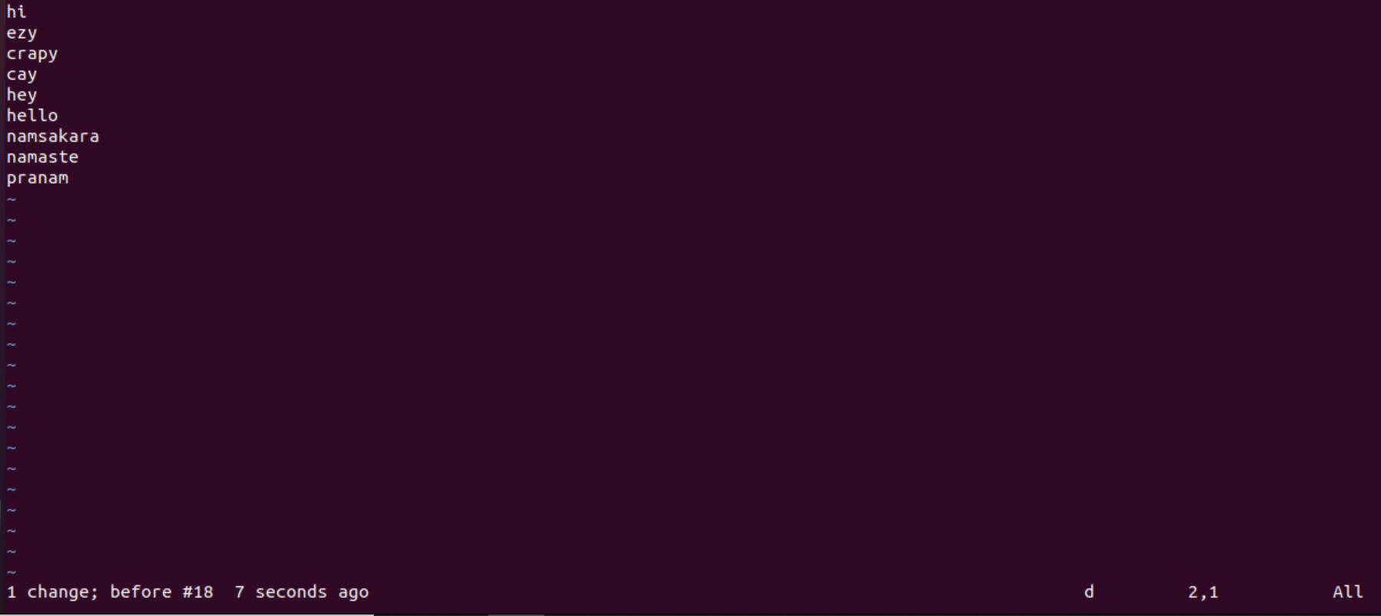

Changes using x key

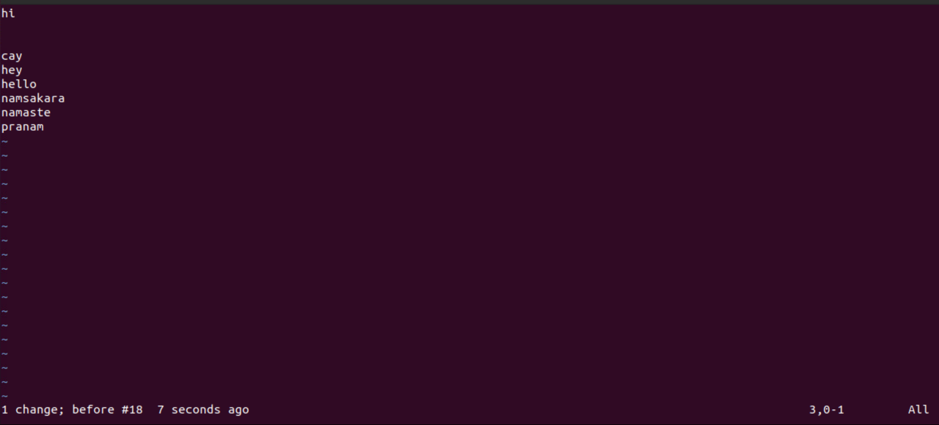

Changes after using d,x,u and saving the file

